**Experiment 9**

**Student Name:** Sahil Kaundal **UID:** 21BCS8197

**Branch:** CSE (Lateral Entry)  **Section/Group:** 616/A

**Semester:** 6th **Date of Performance:** 04/05/2023

**Subject Name:** Data Mining Lab **Subject Code:** 20CSP-376

1. **Aim:**

Study of Regression Analysis using R Programming.

1. **Apparatus / Simulation Used:**

* Windows 7 or above
* R Studio

1. **Objective:**

* Demonstration of the Regression using R.
* Performing the Regression Analysis using R.

1. **Theory and Output:**

**Linear Regression:** It is a commonly used type of predictive analysis. It is a statistical approach for modeling the relationship between a dependent variable and a given set of independent variables. 

**There are two types of linear regression.**

* Simple Linear Regression
* Multiple Linear Regression
* **Simple Linear Regression:**

It is a statistical method that allows us to summarize and study relationships between two continuous (quantitative) variables. One variable denoted x is regarded as an independent variable and the other one denoted y is regarded as a dependent variable. It is assumed that the two variables are linearly related. Hence, we try to find a linear function that predicts the response value as accurately as possible as a function of the feature or independent variable(x).

* **Multiple linear regression**

 Multiple linear regression is a regression model that estimates the relationship between a quantitative dependent variable and two or more independent variables using a straight line.

1. **Code:**

# Importing the dataset

setwd("D:/CU-College/Sem 6/Data Mining")

dataset = read.csv('salary.csv')

# Splitting the dataset into the

# Training set and Test set

install.packages('caTools')

library(caTools)

split = sample.split(dataset$Salary, SplitRatio = 0.7)

trainingset = subset(dataset, split == TRUE)

testset = subset(dataset, split == FALSE)

# Fitting Simple Linear Regression to the Training set

lm.r= lm(formula = Salary ~ YearsExperience,

data = trainingset)

coef(lm.r)

# Predicting the Test set results

ypred = predict(lm.r, newdata = testset)

install.packages("ggplot2")

library(ggplot2)

**# Visualising the Training set results**

ggplot() + geom_point(aes(x = trainingset$YearsExperience,

y = trainingset$Salary), colour = 'red') +

geom_line(aes(x = trainingset$YearsExperience,

y = predict(lm.r, newdata = trainingset)), colour = 'blue') +

ggtitle('Salary vs Experience (Training set)') +

xlab('Years of experience') +

ylab('Salary')

# Visualising the Test set results

ggplot() +

geom_point(aes(x = testset$YearsExperience, y = testset$Salary),

colour = 'red') +

geom_line(aes(x = trainingset$YearsExperience,

y = predict(lm.r, newdata = trainingset)),

colour = 'blue') +

ggtitle('Salary vs Experience (Test set)') +

xlab('Years of experience') +

ylab('Salary')

1. **Output:**

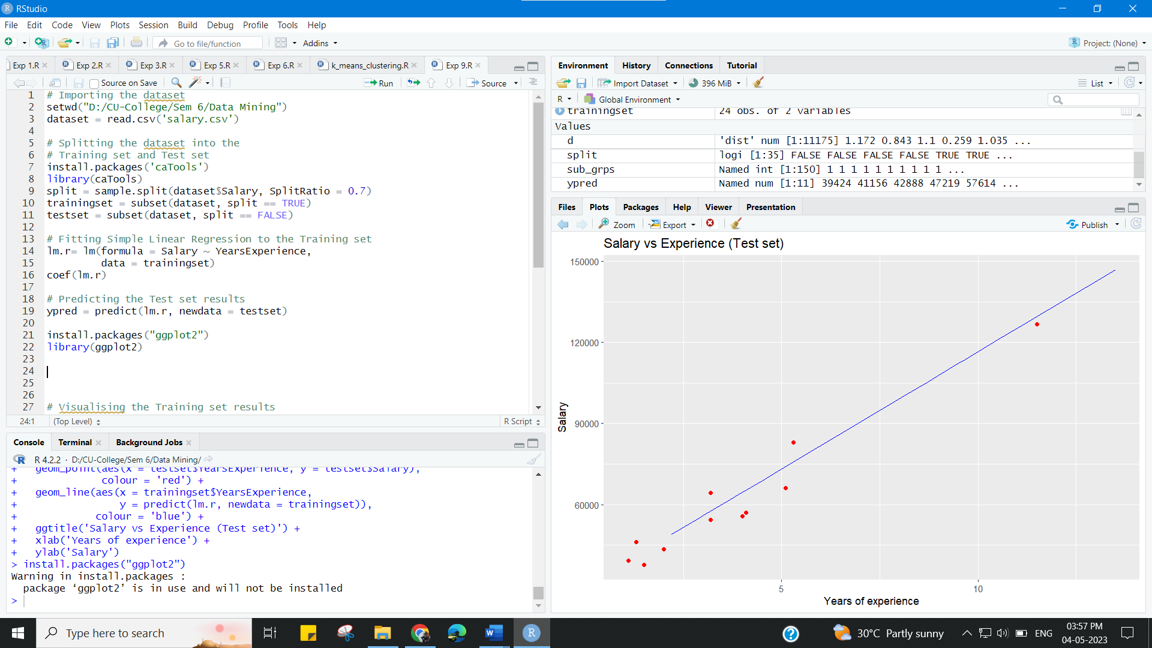

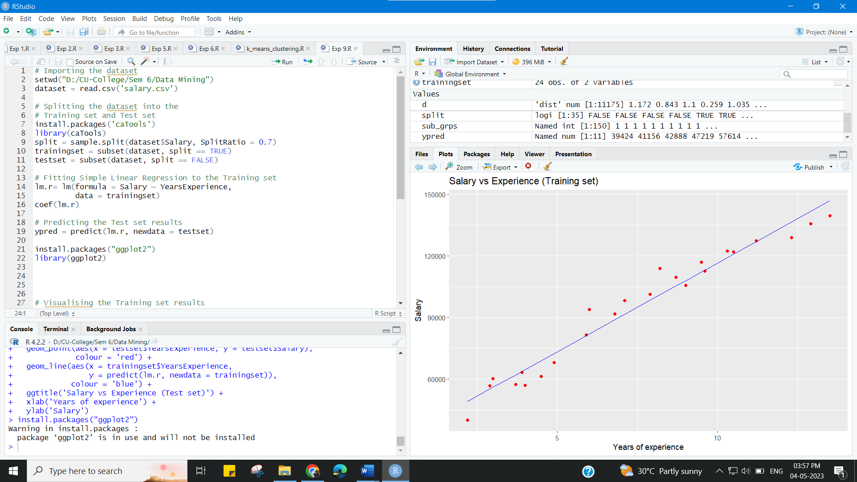

**Learning outcomes (What I have learnt):**

* Demonstration of the Regression using R.
* Performing the Regression Analysis using R.